Irene Wade Belcher  Hall of Honor Award 2010  Presented by the Georgia Baptist  College of Nursing  at Mercer University  by Professor Susan Gunby, RN, PhD  October 15, 2010 | 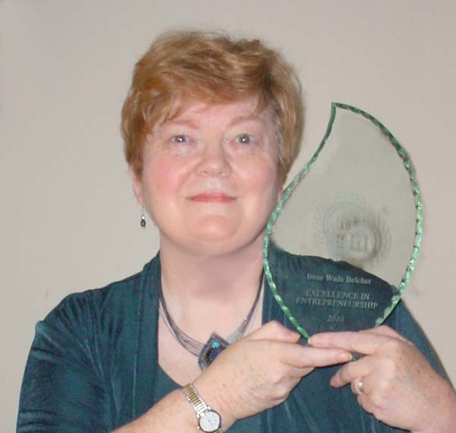

Irene Wade Belcher was inducted into the Hall of Honor in recognition of her entrepreneurial excellence. She graduated from our School of Nursing in 1967. She attended Columbia Bible College for 2 years and then earned her BSN from Medical College of Georgia and her MSN in Adult Psychiatric Nursing at Georgia State University. She is a Certified Massage Therapist.
Upon graduation from Georgia Baptist School of Nursing she worked at Georgia Baptist Hospital as Staff Nurse and later at Emory University Hospital as a Clinical Research Nurse. She was employed as a Community Health Nurse in Dekalb County, GA, and held several positions in Psychiatric Mental Health Nursing.
She was in private practice for many years as a Psychiatric Nurse Specialist and as a Holistic and Complementary Care Consultant. She was the Founder and Executive Director of the Center for Therapeutic Massage & Counseling.
As Founder (1992) and Director of the Atlanta Holistic Nurses Network, Irene spent four years coordinating educational presentations on a multitude of complementary and integrative therapeutic modalities in conjunction with publishing a Network newsletter, HoloGram, for nurses, health professionals, and the lay community.
In 1995 she was given an award from the Alpha Epsilon Chapter of Sigma Theta Tau (the National Honor Society for Nurses) for her research, publications, and accomplishments in Holistic Nursing.
After in-depth training in various holistic modalities she was appointed to the National Board of the American Holistic Nurses Association (AHNA) and served as the Senior Editor for their national newsletter.
And here is where I did not know that this was “our” Irene. She was selected by Drs. Barbara Dossey and Lynn Keegan as one of 40 nurses from the entire world as a Nurse Healer in Profiles of Nurse Healers and I had read that and I did not know that that was Irene.
In 1995 and 1996 Irene was an Instructor of Nursing at Clayton State College. She continued her teaching as an Instructor of Energy Healing and MindBody Concepts at the New Life Institute for Massage Excellence in Atlanta.
In 1999 Irene and Julia Riley, RN, MS, co-founded the Holistic Nurses Institute and began to offer Continuing Education credits to nurses and it is because of her and the work of many of her colleagues that in 2004 Holistic Nursing was officially recognized by the National Board of Certification as an Advanced Nursing Practice.
For all these numerous successes in life and the practice of nursing, we are honoring Irene for her Entrepreneurial Excellence by inducting her into the Hall of Honor of the Georgia Baptist College of Nursing at Mercer University.
Irene Wade Belcher, RN MS NCNMT CNS HNC

