A Few of Irene Floerl Enecks Simmons’s Ancestors and Relatives
Suzanne Belcher, 2009

Julia Margaret Weitman Christie 1819-1887
Irene’s Great Grandmother
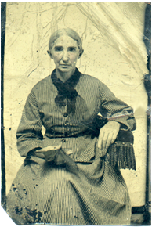 | This picture of is the oldest picture that I know of in the Enecks-Christie family. Julia was the daughter of Salome Waldhouer, a Salzburger. The name “Floerl”, given to Irene and other members of the family, stemmed from Julia’s stepfather, Israel Floerl. Julia was born June 11, 1819, in Effingham County, Georgia; died Apr. 25, 1887. She married Robert Jonathan Christie and their daughters were Anna Sarah Christie and Irene Louisa Christie, both of who whom married James Osgood Andrew Enecks. Anna Sarah was Irene’s grandmother and Irene Louisa was my grandmother. In addition to Irene Floerl Simmons, my mother, known to Irene as “Auntie”, was named Floerl Enecks Smith, my daughter is named Lisa Floerl Flatt and Irene’s Aunt Helen has a granddaughter named Sandra Floerl Natho.

William Robert Enecks, 1st 1810-1894
Irene’s Great Grandfather
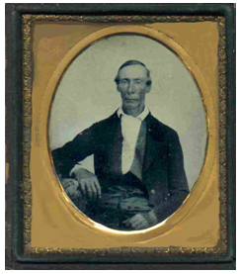 | W.R. Enecks was born in Barnwell District, South Carolina, Oct. 10, 1810, died at his home in Screven County, GA, Sept. 23, 1894, and was buried in the family cemetery across the road from his home. He was a descendant of the Brown and Duke families of Virginia and was married in Augusta, Georgia in May, 1840, to Miss Mary Oswald of Charleston, South Carolina. He moved in 1848 with his wife, four small children and several slaves, from South Carolina to Screven County, Georgia, where he bought a prosperous plantation. Two of his sons fought in the Civil War and returned home safely. Two sons and two daughters lived in the home with him until his death and two others married, built homes near their father's and raised their families there. All are buried in the Enecks Cemetery

James Osgood Andrew Enecks, 1851-1923
Irene’s Grandfather
J.O.A. Enecks was born in Barnwell District, SC, the seventh child of William Robert and Mary Enecks. They named him for a Methodist Bishop, James Osgood Andrew. When he was seven years old, he moved with his family from South Carolina to Screven County, Georgia, near the small town of Newington. The Civil War began three years later, and his two older brothers went away to war. He barely escaped the war, being 14 years old when it ended in 1965. He stayed at home and, no doubt, worked very hard to help his family manage the plantation. Although he was too young to fight, his life was changed forever by the war. Expectations of living the traditional plantation life in the manner of his ancestors were gone with the wind.
Helen Enecks with her Auntie, Irene Louisa, who was JOA’s second wife.

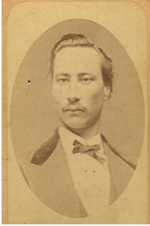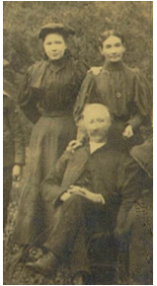

Catherine (Kate) Eliza Enecks Robert Gilmore Simms Enecks
Irene’s Great Aunt and Great Uncle
“Kate and Mollie made their own clothes, dresses much like the popular dirndl of today, straight, tight little bodices sewed on to full circular skirts. They saved their basting threads and used them again and again. Their summer dresses were made of unbleached homespun, buttoned with little pearl buttons. The button holes were miracles of beauty. Miss Kate was post-mistress; the post office was in her own dining room. “
(From article in Sylvania Telephone by Kate Laffitte)

Catherine (Kate) Eliza Enecks,  1842-1922  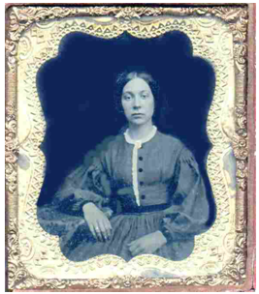 | Robert Gilmore Simms Enecks  1846-1907  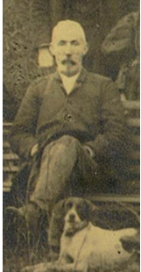

W. R. Enecks, 2nd 1884-1956

Marion Smith Enecks 1892-1973
Irene’s parents
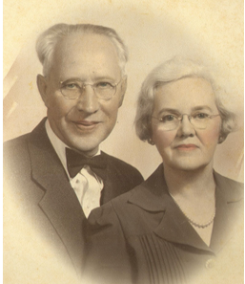

And their Beautiful little Irene

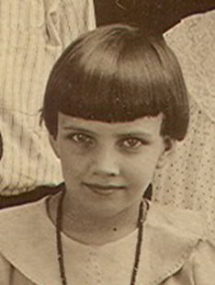

When Will and Marion’s children were young they often brought them home to visit with Will’s Papa (JOA Enecks) and his children with his third wife, Lena Bryan. Papa’s youngest, Jarrell, was about the age of his own nieces and nephews. In the picture on left, back row left to right are Berta and Elizabeth, sisters of Will; front row, Jarrell between Katherine and Parnell, and the baby in front is either Helen or Irene, probably Irene because Helen was nearer the age of Jarrell. On right, Will’s six children were Helen, Parnell, Katherine, Judgie, Irene, and the youngest, Martha.

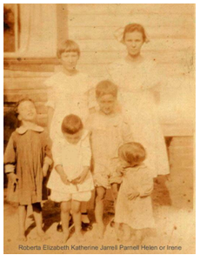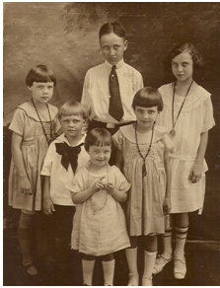

Marion and Floerl, out for a drive in the buggy. This picture was probably taken on the Old Savannah-Augusta Road, when Will and Marion lived across the road from the Gordon Laffitte home and Floerl and Osgood were living with them. Marion is holding her son Parnell and Floerl is holding Helen’s daughter, Sydnor. | 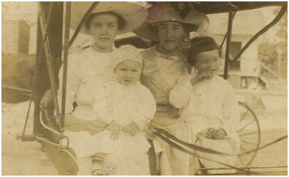

Irene’s Aunts

Aunt Helen Enecks Laffitte  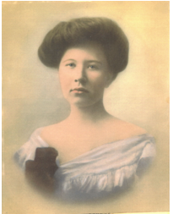 | Aunt Roberta Enecks Conley  Aunt (Auntie) Floerl Enecks Smith  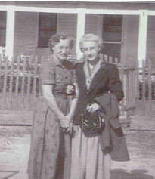 | Aunt Elizabeth Enecks Penrose  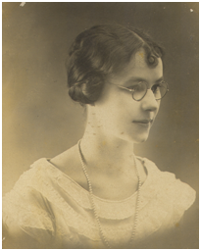

Irene’s brother Parnell and sister Helen when they were both young.

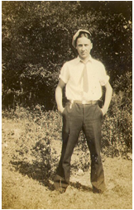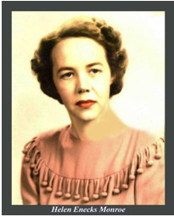

On left, Parnell and Helen, others not positively identified. On right, first cousins, Irene Enecks Simmons, Grace Conley Bland and Suzanne Smith Belcher

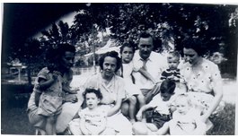

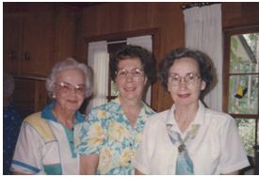

Irene’s home in Rockyford and the main street where her father picked up the mail each day to carry on his delivery route.

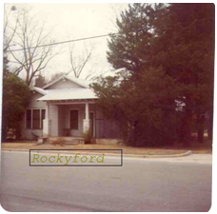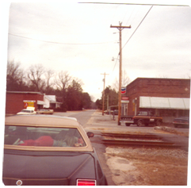

This picture of Irene, which captures her vivaciousness and mischievousness, was taken when she was 86 years old in 2002 at an Enecks reunion in Sylvania, Georgia | 